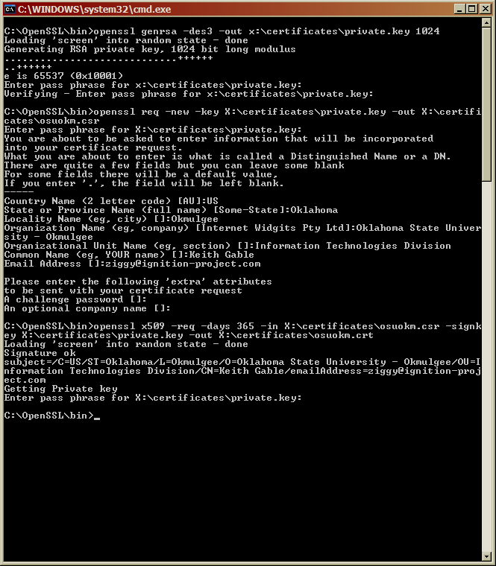

First, I generated my own self-signed certificate using OpenSSL. It’s a lab, why not be creative? ☺

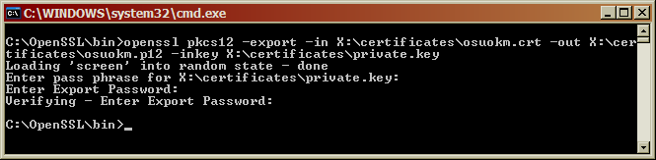

Then, we convert this certificate into a PKCS#12 file.

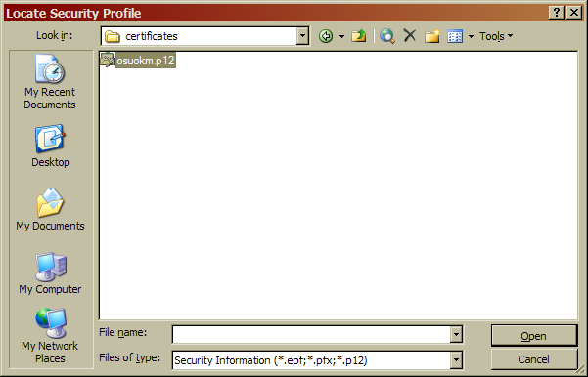

Then load it.

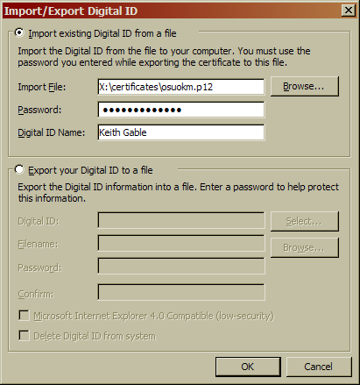

Enter my passphrase.

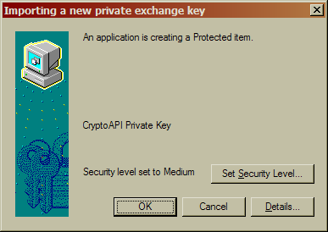

Apparently this is some sort of security dialog, but I don’t see a single real warning about importing a self-signed personal ID…

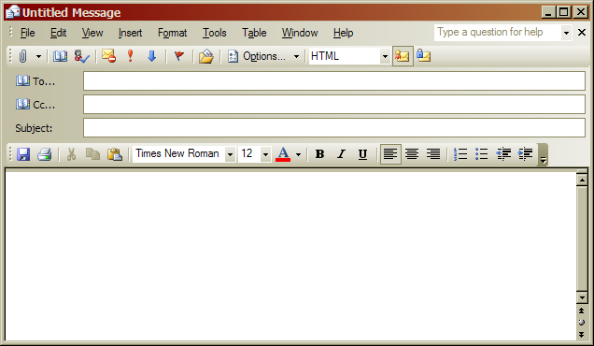

No send option because I have no e-mail accounts that I can add into Outlook. BUT, the digitally sign option wasn’t there before.

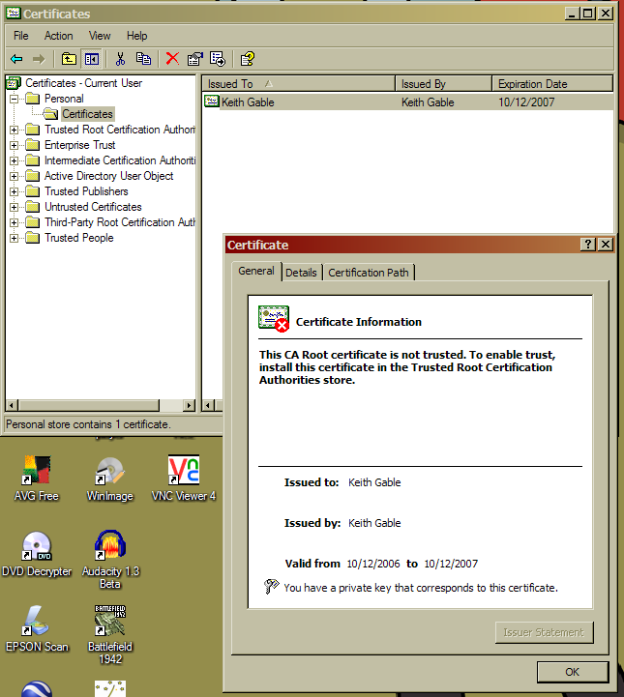

This image is from certmgr.msc to prove that the certificate is installed correctly and that I can sign with it. One thing to note is that it does complain about the “Keith Gable” Root CA. I wonder if I should trust myself…

Summary
Microsoft’s equivalent of PGP is pretty awful. GPG, the free PGP clone, is perfectly usable on Windows, and offers a slightly cheaper (eg. free) way of signing messages should someone want to do that full-time. It’s also easily read by almost every OS. I’ve never heard of PKCS#12 before today. And if it does do the same thing as PGP/GPG, why not stick with the standard? Anyways, I don’t like VeriSign, so I decided to generate my own certificate, sign it, and then generate my own PKCS#12 digital ID. Without outgoing e-mail, it probably doesn’t matter whether or not I signed my digital ID or if VeriSign signed it.

